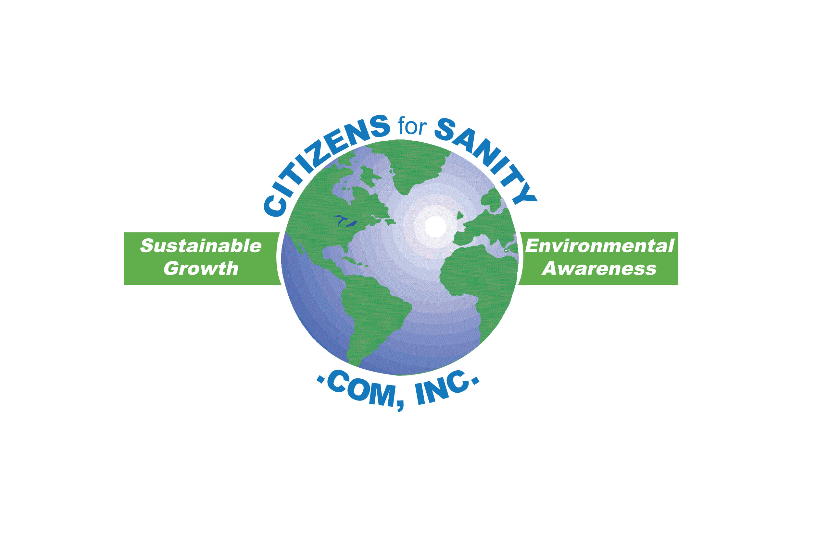
Membership Application

Your membership in Citizens For Sanity is an affirmation of your desire to preserve and improve the quality of life here in Pasco County. Thanks for your past support and your continued interest in:

- Requiring mall developers to preserve wetlands & sensitive ecosystems.
- Supporting scientific growth management practices
- Insisting on concurrency—the approval of new developments only after
infrastructure is in place (roads, schools, police, fire services etc.)
- Making growth pay for itself
- Preserving open spaces and establishing wildlife corridors
- Insuring that elected county representatives and staff strictly adhere to the Comprehensive Plan

Citizens For Sanity needs your continued support. Together we can make a difference.

----------------------------------------------------------------------------------------------------------------------------------------------
Membership Application

No address change from previous application

Please make the following changes
Individual membership | $ 10.00
Family membership | $ 15.00
Corporate/Group membership  Lifetime  Legendary | $ 25.00  $300.00  $500.00

Name ___________________________________

Address __________________________________

City _________ State______ Zip___________ Tax Deductible Contributions(501c-3)
All contributions receive a letter of acknowledgement
Phone ( _____ ) _________________ with our (501c-3) tax-deductible ID number.
(membership dues are not deductible)
Email @___________________
Citizens For Sanity.Com, Inc
19840 State Road 54
Lutz, FL 33558
813-949-4628

